**Group: 6**

Fire Station Management System

Submitted to:

**Sajjadur Rahman**  
Lecturer, Dept. of CSE

**Johra Muhammad Moosa**Lecturer, Dept. of CSE

Submitted By:

SadiaAtique(1005013)  
TasminChowdhury(1005025)  
AmanUllahAman(1005026)  
Md. Abdullah Al Fahim(1005028)  
Hasanul Aziz(1005030)

**Subsystems:**

1. Employee Management System
2. Resource and Equipment Management System
3. Fire Response System
4. Post fire Management System

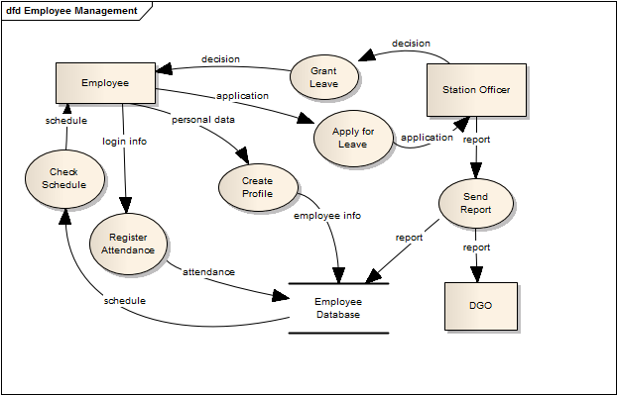**Employee Management System:**

Figure 1: Data Flow Diagram of Employee Management System

**Data Flow Diagram:**

**Course of Events:**

* + When a new employee joins in the fire brigade station he will apply for the registration with his personal information
  + Then system will create a user profile for him where he will be notified about their work schedule
  + His attendance will be automatically kept logged in the employee database after he logs into the system.
  + User can also apply for their leave. they will send the application to the station officer via system
  + Station officer will then decide considering the current circumstances if the leave is grantable
  + If the leave is granted then he notifies the employee through system and keeps a log of the leave history into the employee database
  + Station officer will also make an annual report on every employee about their work performance and send it to District General Office to inform the director general about the current status of the employees
  + Data operator then saves the employee reports on the database

**Fish-Bone Diagram:**

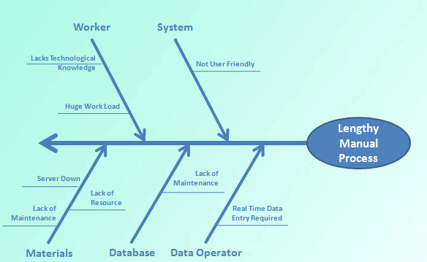**Description:**

Figure 2Fish Bone Diagram for Employee Management System

* We are mainly maintaining a database of workers which requires general workers of fire stations to log into the system and perform various task. That requires certain knowledge about technology which they might lack
* root level user might find the system not user friendly
* as workers need to log into the system frequently computers may not be available and such type of logging may also cause server down
* If database is not maintained properly by data operator, it might cause problem and data loss.

**Resource and Equipment Management System:**

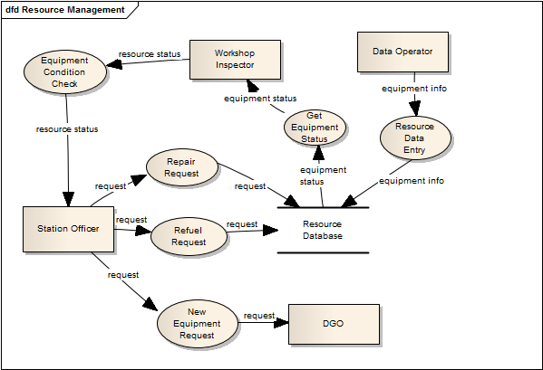 **Data Flow Diagram:**

Figure 3: Data Flow Diagram of Resource and Equipment Management System

**Course of Events:**

* After getting the weekly notification of the equipment and fuel checking, workshop inspector will check the current status of the equipment and fuels from the database.
* Then he will make a report on the equipment and fuel checking provided by the system and saves the current status into the database
* And system will forward the report to the station officer
* Station officer will take initiatives for refueling and repairing
* After refueling and repairing , current condition of the equipment and fuel will be updated in the system by data operator
* Station officer can also request Director General Office for buying a new equipment if necessary

**Fish Bone Diagram:**

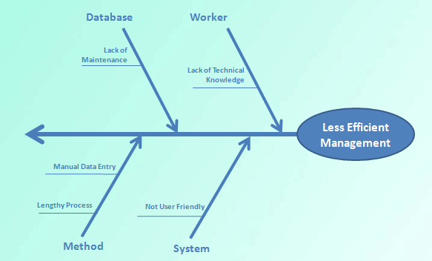 **Description:**

Figure 4Fish Bone Diagram for Resource and Equipment Management System

* The system requires general workers of fire stations to log into the system and perform various task. That requires certain knowledge about technology which they might lack
* Root level user might find the system not user friendly
* as workers need to log into the system frequently computers may not be available and such type of logging may also cause server down
* as data entry method is manual, it is lengthy and not efficient

**Fire Response System:**

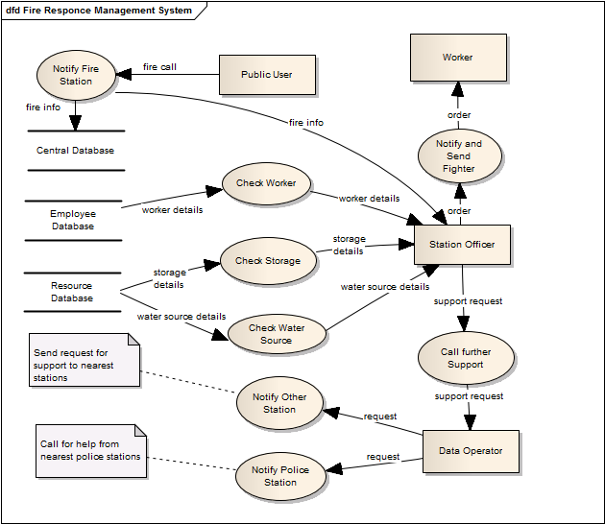 **Data Flow Diagram:**

Figure 5: Data Flow Diagram of Fire Response Management System

**Course of Events:**

* Public User notifies fire station for help and that eventually sent to station officer.
* Station officer checks resource database to know the current storage details.
* Station officer retrieves data from resource database for water source location.
* Station officer checks current worker from Employee Database to send appropriate workers.
* Station Officer posts order to workers.
* In case of necessity station officer conveys request for support to Data Operator.
* Data operator then requests for support to other fire stations.
* Data Operator requests for Support to respective police stations.

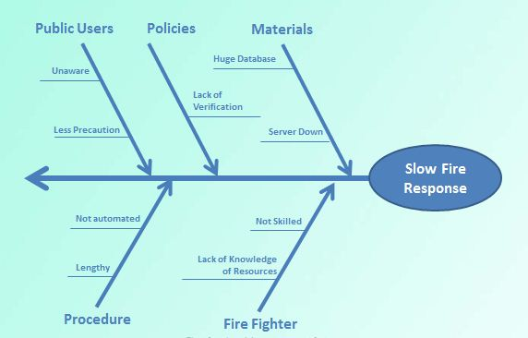**Fish-Bone Diagram:**

Figure 6: Fish Bone Diagram for Fire Response Management System

**Description:**

* Public users are required to give data about fire occurrence . they might lack technical knowledge which might cause problem
* sometimes station might get fraud calls , so system will hammered unnecessarily
* public user need to contact fire station frequently which might make server break down
* Fire response Procedure might be lengthy as it is not fully automated
* Fire fighters might lack skill which will cause problems

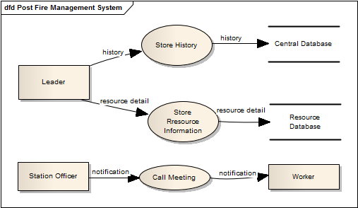**Post fire Management System:**

Figure 7: Data Flow Diagram of Post Fire Management System

**Data Flow Diagram:**

**Course of Events:**

* After a fire response Leader Store History of the fire incident to Central Database.
* Leader also stores resource information to the Resource Database.
* Station Officer Calls Meeting for analyzing the firefighting incident and notification of meeting is sent to the workers.

**Fish-Bone Diagram:**

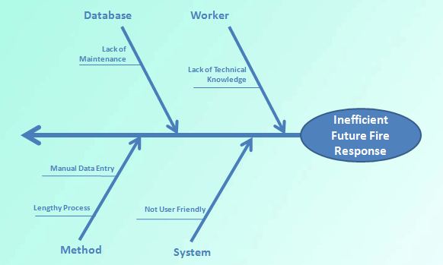 **Description:**

Figure 8: Fish Bone Diagram Post Fire Management System

* If database is not maintained properly by data operator, it might cause problem and data loss
* The system requires general workers of fire stations to log into the system and perform various task. That requires certain knowledge about technology which they might lack
* System might not be user friendly
* This Procedure might be lengthy as it is not fully automated

**Feasibility Analysis:**

**Operational Feasibility:**

* We will create an user friendly fire response system for the public for any kind of fire break out
* We will create a database of all the workers personal information. It will help us knowing any information about any worker worked or working in the fire station.
* We will maintain a database of the infrastructures of a particular city and the nearest water resources, police stations and hospitals info will also be kept in the database.
* Our system will improve the communication system among the employees and stations
* All fire history will be logged into the system for the future analysis
* We can also be informed about the current status of the equipment available by keeping equipment information in the database

**Cultural Feasibility:**

* Public will get an easier and quick response system for any fire break out
* Employees are benefited largely due to availability of the information and notification system
* Grounds will be kept under keen observation so that a good number of firefighters will be always ready when a fire breaks out
* All the leaders will find it easy to select and manage his team members.
* Station officer will be benefitted by the easy processes of his work by the system and also in observing the works of the every employee
* DGO will find the system user friendly while forwarding any approval and doing necessary confidential works

**Technical Feasibility:**To implement this system, we used

* Java for Smart Phone app
* PHP for Server Side Scripting
* JavaScript for Client Side Scripting
* Oracle for Database
* User Friendly designing will be dealt by Engineers

**Practical Implication:**

* System engineers will monitor any malfunction.
* Versioning of the system will be maintained.
* System maintenance cost will cover any maintenance issue.

**Cost Analysis:**  
Cost can be categorized into two parts. The development cost and Annual operating cost.

**Development Costs:**

|  |  |  |  |
| --- | --- | --- | --- |
| Sector | No of Employee | Time Period | Cost |
| System Analyst  (35k/month) | 2 | 4 months | 280000 |
| Programmer  (40k/month) | 3 | 3 months | 360000 |
| GUI Designer  (40k/month) | 1 | 1 month | 40000 |
| Database Specialist  (40k/month) | 1 | 2 months | 80000 |

**Total Development Costs: 760000 BDT.**

Annual Operating Costs:

|  |  |  |
| --- | --- | --- |
| Sector | No of Employee | Cost |
| Data Operator  (15k/month) | 1 | 180000 |
| System Maintenance  (25k/year) | -- | 25000 |
| Domain  (5k/year) | -- | 5000 |
| Server Hosting  (5k/year) | -- | 5000 |

**Total Annual Costs: 215000BDT**

**Cost-benefit analysis:**

As we are implementing the project as if Fire Brigade is developing it, there is no monetary benefit associated with the project. So cost-benefit analysis part is discarded.

**Tangible Benefits:**

* Decrease fire response time
* Manage equipment efficiently
* Manage workers efficiently
* Reduce paper works
* Automate fire station

**Intangible Benefits:**

* Improve fire response system
* Confidence increased after successful operation
* Technical knowledge improved
* Modern technology introduced
* Reputation Increased
* Better communication system between fire stations
* Improvement in fire station management